Finance Manager - Farming
Job Holder’s Title:

Head of Business Finance
Reports to:

None
Direct Reports:

Agrial Fresh Farms with support into BUUK
Site Responsibility:

Main Purpose of the Job
With responsibility of the production of AFF’s P&L and business partnering the farming operation. Also supporting the wider business finance function in its mission to maximise profitability.
Scope of Responsibility
Management Accounting
Business Partnering
Financial Accounting (Supporting our financial control team in Lichfield)

Team Structure
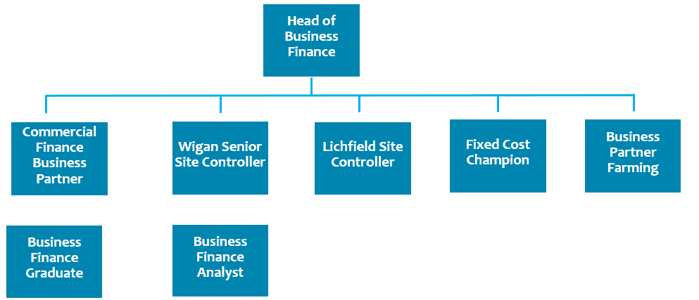

Main Responsibilities
Monitor the performance of the farm through P&L and variance analysis management. In order to obtain this, timely and accurate data in the database is essential and this role oversees this process. Persistent review and challenge of this is paramount to having accurate accounts and the ability to add as much value as possible

Partnering:
a) Farming Manager and their direct reports
b) BUUK Procurement and Supply Chain Director and their Procurement team
Produce weekly P&L reporting with detailed analysis to create best in class visibility of the performance
Enhance variance analysis with tight controls on yield, wastage, labour and other costs
Month end – completion, WIP accounting, margin analysis, minimal weekly to monthly reconciliation issues
Post Month end – Rolling forecast, profit improvement plan tracking and forecasting
Balance Sheet – Monthly reviews. The FBP is responsible for all balance sheet items, with particular focus needed on WIP, stocks and accruals/prepayments.

Project support – Whether that be in business finance, finance or operations. Examples such as:
- Site Control support and optimization of processes
- Conducting standard cost reviews and challenge each standard
- Driving CI and PIP activity
Support the Farm team with their internal controls (Database, timesheets & forecasting)
Assist Finance Control with the audit and statutory obligations
Complete annual budget and the 3 year business plan. This is full P&L ownership and completing all group templates and presentations required.

Continually review and challenge internal controls and recommend any changes
Capex management and liaison. Return on investment tracking is of particular importance
Carry out any other reasonable requests as required by management

Key Performance Indicators
1. | Accuracy of information provided
2. | Respect of the reporting deadlines
3. | Quality and relevance of recommendations given to the business
4. | Minimal weekly to monthly reconciliation variances

Limits of Responsibility

Skills and Experience
1. | CIMA Qualified – Post qualified at least one year.
2. | Proficient in Microsoft Office – especially Excel. Use of Power BI is desirable.
3. | Experience within FMCG/WIP accounting is desirable
4.

Personal Qualities
1. | Hybrid working is offered – expectation of minimum 3 days in office per week. Occasional travel to Lichfield required.
2. | Ability to work under pressure and lead by example
3. | Ability to solve problems and make decisions
4. | Accuracy and attention to detail
5. | Motivational skills - Self starting is essential and self efficient due to being the only finance representative on site
6. | Communication and good interpersonal skills

Other Duties
This list of duties is not intended to be exhaustive but gives a general indication of tasks and responsibilities. All employees are expected to work in a flexible manner and acknowledge that tasks not specifically covered in their job description are not excluded.

Job Holder Name: | Job Holder Signed: | Dated:
Signed on behalf of Agrial Fresh Produce Ltd. |  | Dated

