Responsible to:
QA Manager

Day Hygiene Operative
Job Holder’s Title:

Main Purpose of the Job
Ensure that all amenities are cleaned and sanitised to a high standard, maintaining a clean and safe environment that assists and reflects the values of the company.

Human Resources Team Structure
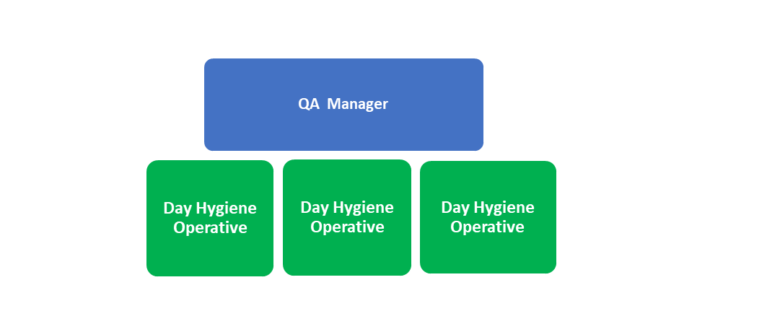

The list of duties is not intended to be exhaustive but gives a general indication of tasks and responsibilities. All employees are expected to work in a flexible manner and acknowledge that tasks not specifically covered in their job description are not excluded.
Key Accountabilities
Ensure that the amenities cleaning is carried out effectively according to schedules and company standards.
Ensure all the rules and regulations relating personal hygiene and statutory health and safety requirements are always met.
Ensure that company quality and food hygiene standards and procedures are strictly adhered to at all times.
Ensure that cleaning methods / procedures are adhered to.
Replenish hand soaps and towels as and when required.
Replenish production overalls as and when required.
Remove rubbish from office and production areas.
To ensure all completed work is signed off accordingly.
Consistently work effectively and also within safe working practices.
Ensure safe handling of all chemicals, in line with instructions at all times
Always use the correct protective clothing and equipment and perform in the role in a safe and effective manner.
Communicate effectively and work co-operatively within the cleaning team
Assist/ train in the introduction of new staff under the guidance and advice of the Site
Effectively comply with Company Policies and Procedures e.g. Health & Safety, Training & Development, Quality, disciplinary & Grievance and Sickness & Absence.
Ensure compliance and commitment to the company’s standards on ethical people management (in line with the ETI Base Code). Ensuring systems are in place to monitor and promote ethical working both in your won and your team’s day to day working activities.

Health and Safety Responsibilities
To ensure company and statutory Health and Safety regulations and requirements are met at all times.

General:
- know, understand and comply at all times with operational rules and health and safety procedures applicable to you
- assist any colleagues or visitor in the event of a hazardous situation or act
- reach out to your supervisors, particularly when it comes to health and safety issues
- report minor accidents, near-accidents and hazardous situations
- report ideas for improvements

Within your scope of work:
- participate in risk assessments related to your teams, activities, work environments and new projects
- if necessary, help implement the defined prevention measures and initiatives (risk assessment, prevention programmes)
- if necessary, participate in analysing the causes of any significant events (lost-time accidents, non-lost-time accidents and significant near-misses)
- participate in discussions with managers on the behavioural aspects of prevents (behavioural safety visits, safety starts with me observations, etc)
- participate in information and communication initiatives carried out by managers (e.g. prevention minutes, safety contacts, etc)
Key Performance Indicators
1. | Site Health & Safety performance and BRC standards and results.
2. | Teamwork and communication with other departments.
3. | Flexible approach towards work and prioritising skills
4. | Maintain cleaning standards throughout area of responsibilities.
5. | Management of PPE and cleaning material stock.

Person Specification
The Person Specification is designed to establish the necessary qualities, skills, knowledge and qualifications that the ideal post holder would need in order to effectively carry out the position. The selection process will use this information to benchmark applicants, when short listing for interview. Once a person is in post their training and development needs will be assessed against these criteria and will become an integral part of the objective setting process.
Qualifications | Essential | Desirable
Maths and English Language GCSE or equivalent (Level 2) |  | √
Basic Food Safety Certificate |  | √
Chemical Training |  | √
Health and Safety at Work Certificate |  | √
Knowledge and Experience | Essential | Desirable
To have 1 years’ experience in hygiene operative role | √
To have 1 years’ experience in a Manufacturing environment | √
To have 1 years’ experience in the food industry |  | √
Awareness of hygiene standards and regulations in the workplace | √
Skills | Essential | Desirable
To be able to follow and complete instructions | √
To have good written and spoken communication skills | √
To be able to carry out repetitive and routine tasks | √
To be able to quality check working standards and practices | √
To have a high attention to detail | √
Core Requirements | Essential | Desirable
Confidentiality in respect to your own job must be maintained at all times. The integrity of the information you work with and are privy to should be treated with due respect and consideration. | √
It is imperative that no discrimination takes place against any member of staff and that the company’s equal opportunities policy is adhered to at all times. | √
You should ensure that all Health and Safety standards are maintained and that you show due diligence at all times. You should report any bad practices to the Health and Safety Manager. | √
All work carried out during your hours of work should impact on the achievement of objectives for the role. | √
Effectively manage and comply with company policies and procedures e.g. health & safety, training & development, quality, disciplinary & grievance and sickness & absence etc. | √
To carry out any other duties, commensurate with the role, as directed by the management team to meet the objectives of the business. | √

Job Holder Name: | Job Holder Signed: | Dated:
Signed on behalf of Agrial Fresh Produce: |  | Dated

